Horncliffe Parish
A Spring Bulb Show
to be held at the
Horncliffe Village Hall
on
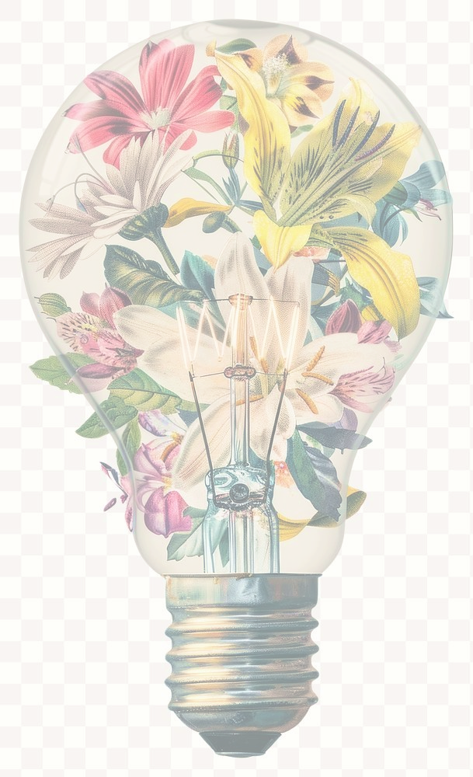
Saturday 28th February 2026
Starts 10.30am
Presentation of prizes 12.30pm

All entries are free
Welcome to the Horncliffe Parish Spring Bulb Show 2026.

We are delighted to invite you to the annual celebration of springtime colour and community creativity. Whether you are an experienced gardener, a first-time grower, a baking enthusiast a keen artist, there is something for everyone. This friendly, informal show is all about sharing the joy of gardening, plants, flowers, art and food — and most of all, having fun together as a village. We hope you enjoy taking part or simply coming along to admire the entries and enjoy a good chat over tea and cake.

Firstly, it needs to be fun.
We have set some simple categories and some guidance for first timers for the bulb categories. You can enter as many categories as you wish. We have also added a children’s category although they can enter any category. Best of all entry is free.

Page 1

The Categories Spring Bulb Category
- One bowl/pot of Hyacinths.
- One bowl/pot of Daffodils or Narcissus.
- One bowl/pot of Tulips.
- One bowl/pot of any other Bulbous Plant.

Indoor Plant Category
- One miniature garden.
- One indoor Foliage Plant.
- Flowering Plant or Cactus.
- One flower arrangement.
Picture/Photograph of Spring Flowers Category 1. One picture/photo of spring flowers (children’s category).
2. One picture/photo of spring flowers (adult category).
The Baking Category 1. Breads/Rolls etc.
- Chocolate cake
- Lemon cake
- Cherry cake
- Scone sweet
- Scone savoury
- Tray bake 4 pieces

Page 2

Judging Criteria and entry requirements

All categories will be judged based on the following general criteria:
- Condition – Healthy, fresh, well-presented plants or produce
- Presentation – Neatly staged and arranged with care
- Suitability – In line with the category’s requirements
- Creativity – Especially for miniature gardens, flower arrangements, and picture/photos
- Taste & Texture (for baking) – As judged by our local tasters.

Note: The judging is friendly and informal — we encourage everyone to have a go, regardless of experience.

If you are entering the show please bring your exhibit to the village hall by 9.00am on the morning of the bulb show. Alternatively if you cannot make it that early you can bring your exhibit to the village hall on the evening of Friday 27th February between 6.00pm and 7.00pm.

Page 3

Please have the name and telephone number of the person/group entering the exhibit placed under the exhibit. All exhibits must be removed after the show.

Remember there is no charge for entering the show and you can enter as many exhibits as you wish. There will be a donation box if you wish to donate money to the event.

A guide to growing and preparing bulbs for the bulb show:

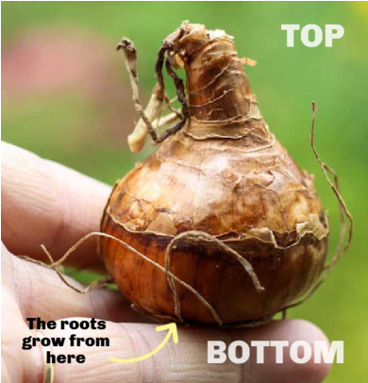

There is no mystery or secret to growing bulbs for the show it’s all in the timing!

Plant your bulbs between late September early October for the show in February 2026.

There is no need to buy expensive bulb fibre as ordinary potting compost is adequate as long as the container is free draining. A 50/50 mix of potting compost and leaf mould or garden compost plus some grit and a sprinkling of slow release fertiliser can be used.

Hyacinths 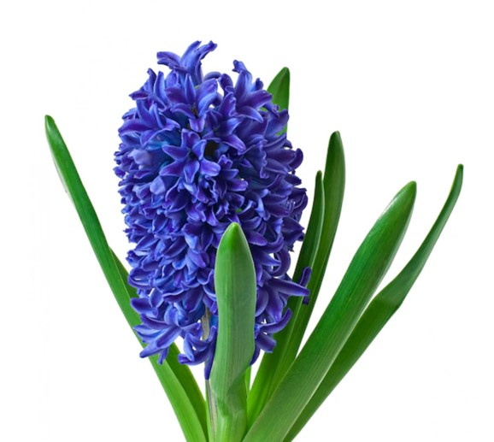
1 or 3 bulbs in any size pot. Fill ¾ of the way with compost and plant bulb/s, top up, leaving top of bulb showing. Water and leave in frost free dark, cool shed or garage. Keep soil damp (and slug free) until Christmas. After Christmas bring emerging bulbs into the house keeping cool with good light to start with. Move to a warmer spot nearer the show time to encourage bloom. Keep watering and stake if necessary. You can grow a single hyacinth in a suitable glass vase, with water barely touching the base of the bulb

Tulips 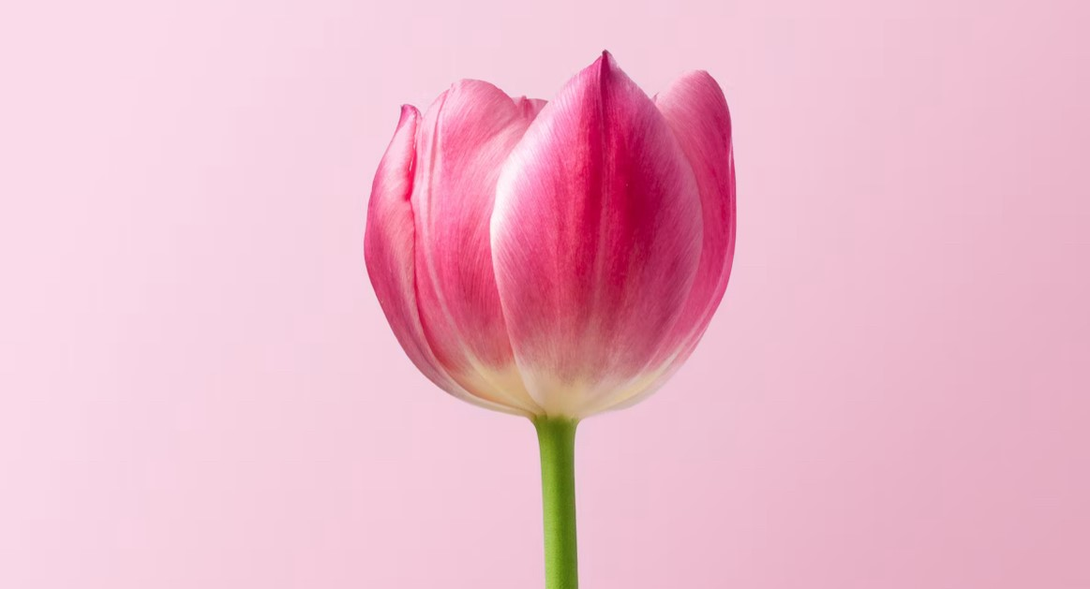
5 bulbs in any size pot – unlimited amount of dwarf tulips in 10” diameter pot, or less. Fill pot with soil and plant bulbs half way down. Water and store outside in sheltered position. Protect from mice, birds and slugs. After Christmas bring emerging bulbs into the house keeping cool with good light to start with. Move to a warmer spot nearer the show time to encourage bloom.
Keep water and stake if necessary.

Daffodils 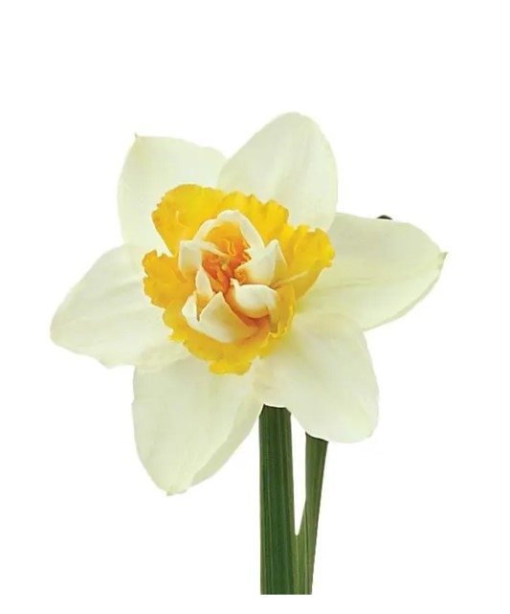
Pot diameter 6” or 10” apart from singly grown trumpet daffs and paper whites, all other daffs can be planted in several layers of compost and bulbs. To achieve this, choose a deeper container, place about 1” of compost in the base of the pot and add as many bulbs that can be accommodated without touching. Just cover with soil and repeat the process until the pot is full. It does not matter if the top layer of bulbs is protruding. Water and store outside in sheltered spot.

Crocus 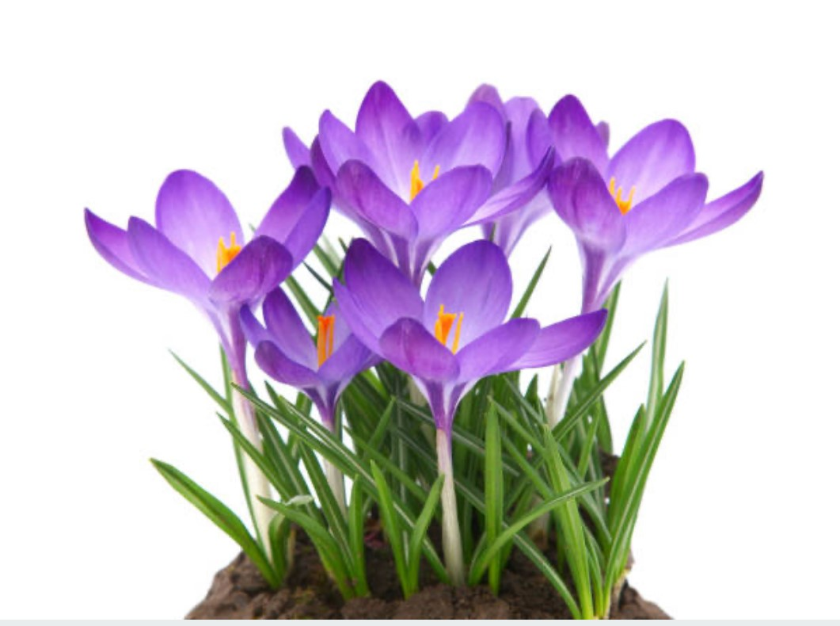
4” pot for mini crocus and 10” pot for larger flowering varieties. Plant as closely as possible without touching, one inch deep. Top up with gravel and sprinkling of pepper to deter mice. Keep outside top up with pepper as required.

IRIS 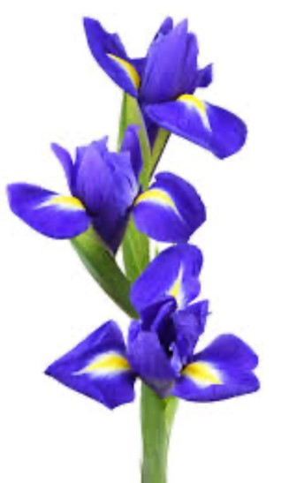
Any size pot and plant as above, topping with gravel and pepper and keep outside as with crocus. After Christmas bring emerging bulbs into the house keeping cool with good light to start with. Move to a warmer spot nearer the show time to encourage bloom. Keep water and stake if necessary.

Page 7

Amaryllis 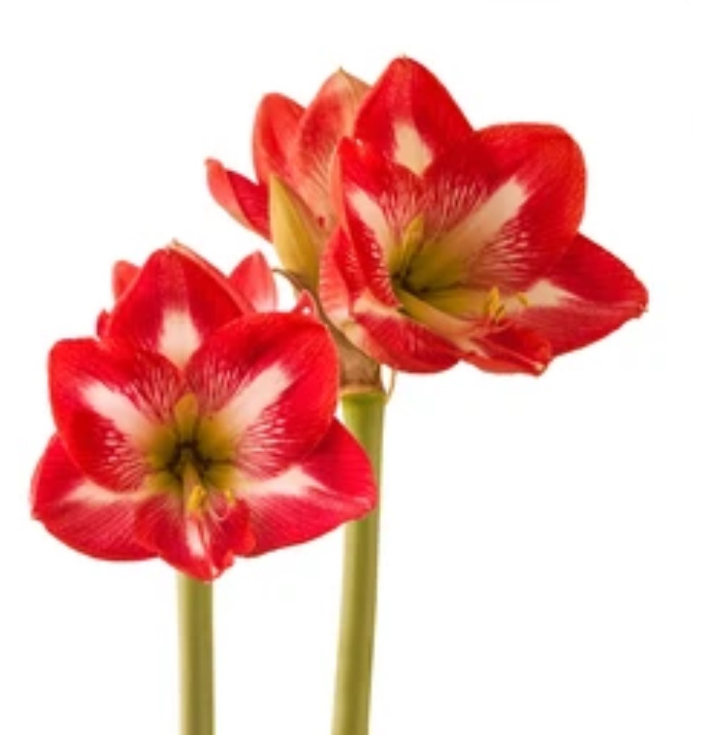
Follow supplier’s instructions, planting at least 8 weeks before the show. Leave in warm place such as airing cupboard until shoots appear, then warm sunny window sill. Give support to flower stems and be careful not to over water.

Suitable Bulb Varieties

Hyacinths | Pink | Fondant, Pink Pearle
 | Blue | Delft Blue, Blue Jacket
 | White | Aiolos, Carnegie, L’Innocence
 | Special | Jan Bos
 | Other Colour | Purple Sensation
Daffodils | Trumpet | King Alfred, Dutch Master
 |  | Gigantic Star
 | Cup | Ice Follies, Pink Charm,
 |  | Johann Strauss
 | Mini | Tete a Tete
Page 8

Tulips Mini The First
Normal Apricot Beauty

IRIS Purple Gem, Blue Bird,
Katharin Hodgkin,
Reticulata, Gypsy Girl,
Sheila Ann Germany

Crocus 4” Pot mini Firefly, Cream Beauty
10’ Pot Vanguard, Pickwick,
King of Striped

Amaryllis Aphrodite, Alfresco, Apple Blossom,
Flower Record

Contact details for any questions:
Mark Inwood Tel: 07961351032
Email: Mark.Inwood@hotmail.com
Jacquot Dansie Tel: 01289 382409
Email: Jdansie125@btinternet.com

Page 9

Notes

____________________________________________________ ____________________________________________________

____________________________________________________ ____________________________________________________ ____________________________________________________ ____________________________________________________ ____________________________________________________ ____________________________________________________ ____________________________________________________ ____________________________________________________ ____________________________________________________ ____________________________________________________ ____________________________________________________ ____________________________________________________

