 | Keeping Our Community Connected  Welcome to the  June/July 2026 edition

Welcome to this edition of Horncliffe newsletter. It is a pleasure to bring you village news, events, and updates whilst we enjoy the summer light that lingers just a little longer each day. Whether you’re a lifelong resident or new to the village this newsletter is for you
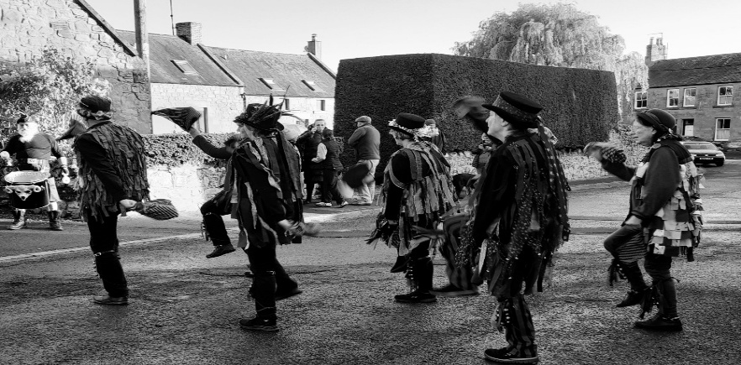
Ragbag Border Morris outside the Fishers Arms
All welcome to come and ‘have a go’ on practice Tuesdays.
Contact Graham on 07943 866861 for information

Spotlight on: Horncliffe Music and Beer Festival 4th and 5th July 2026
It’s that time of the year again when we are looking forward to warm summer days, live music and tasting some fine local beers. This will be the sixth year of this event which a small but dedicated team of volunteers started in 2019.
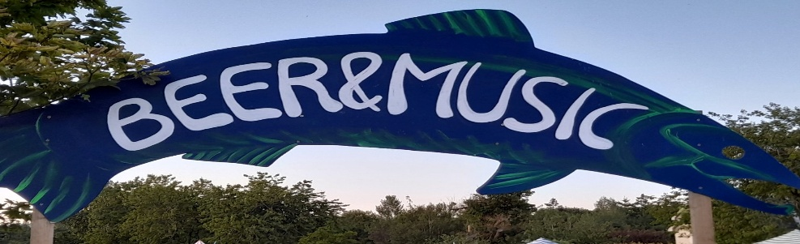
We had to take a couple of years off in 2020 and 2021on the instruction of Boris Johnson but came bouncing back in 2022 with a terrific line up of music and tasty beers and since then it’s been an annual event on the village calendar, attracting visitors and entertainers from the local area and further afield. This year we kick off the weekend on Friday night with a launch party in The Fishers Arms, music provided by the ever popular Salmon City Blues Band. On Saturday, the main bars and live music will be in the Memorial Hall, starting from midday and running until 11pm. This years headliners are Nottingham based band Dirty Ruby who were UK Blues Federation nominees for Best Emerging Band in 2025 and 2026. They are of course the icing on the cake of an eclectic and excellent mix of acts including local favourites The Honey Badgerz and some visitors from as far afield as Teesside and central Scotland.

You’ll be able to quench your thirst and sample some great beer and cider from the main bars. This year we welcome back Cheviot Brewery and First and Last who will have a range of quality beer available. Local resident Andy will be providing our cider bar showcasing some of Sandford Orchards finest produce. Sunday kicks off with Alnwick Pipers Society and has a slightly more mellow feel with some folk and jazz acts through the afternoon before revving up to a lively evening with local favourite Jenny Biddle, the high energy Jon Palmer Trio who will have you singing their choruses until you can sing no more and then if you’ve got any energy left you can finish the weekend as we started, dancing and bopping with the Salmon City Blues Band.

There will be dancing from Rag Bag Border Morris (Saturday) and Luna Nigra (Sunday) and also some pop up acoustic acts in The Fishers Arms during both afternoons. Food offerings will include fine Thai Cuisine at the Memorial Hall from Thon Thai and the usual tasty cakes, tea and coffee. Should be a great weekend, make sure you put it in your diary and most importantly come along and have a great time!
For more information check out our website:
www.horncliffeevents.co.uk/horncliffe-beer-music-festival
Thanks to Nick Allmark for this timely and appealing invite

Horncliffe Dog Show
We had a fantastic turnout on a beautifully sunny day for the 3rd Annual ‘Fun’ Dog Show. Nineteen enthusiastic dogs, accompanied by their eighteen equally enthusiastic humans came along to compete for the coveted title of Best in Show. Our four-legged (occasionally two-legged) friends pranced, around showing off their agility, clever tricks, waggy tails and irresistible eyes.
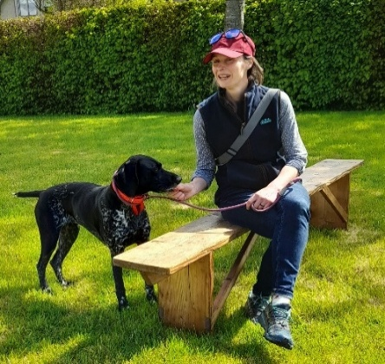

Local Heroes
Horncliffe villager Jim Lang and buddy Gordon Sutherland completed their awesome 215 mile walk in 15 days and sponsored by 660 generous people, raised over £6,600 for The Grove Special School in Berwick. The fund will help the school purchase a minibus and make a difference to young people. What better? Well done Jim and Gordon.

Notices & Reminders
- Fishers Arms -  please check The Fishers lovely website or front window posters for up-to-date information and events.
- Chainbridge Honey Farm – the Bus Café is open Wednesday to Sunday 10 am – 4pm and the Visitor/centre shop open 7 days a week 10am – 5pm.
- Horncliffe Through the Lens Photo Competition 2026 – this year proceeds to Horncliffe in Bloom. The theme for the 2027 calendar is ‘Blooming and Wild About Horncliffe’. See posters and entry packs in the Fishers Arms and memorial hall.
- Libraries Consultation 2026 - Northumberland County Council has launched a consultation about how best to run the service in future. Everyone can have their say online https://nland.cc/libraries-survey or collect a paper version from Berwick library and at the Town Clerk’s office. The survey is open until 30th June 2026.
- Parish Council Meeting: Next meeting at the Memorial Hall will be on the Tuesday 7th July at 7 pm All welcome.
- Heating Oil – Horncliffe Buying Group. The deadline dates in 2026 for your fuel order are (Thursdays): 16th July and 15th October. Please call June on 01289 382683 no later than that date.
- Horncliffe in Bloom are a voluntary group who keep our village looking pretty all year round. They are always grateful for any volunteer help on an ad-hoc basis, without any commitment to further involvement. This has proved very useful for ‘holiday relief’ watering, and grass cutting. If you’d like to join the Volunteer WhatsApp group, please contact Gwyneth: 07854 912051
- Tracks and Tales will start soon – A regular walking and writing event watch for posters in the village hall and Fishers Arms and online,
- Get Involved – submit your news and stories by email to: newsletterathorncliffe@gmail.com or post through the letterbox at Waltham Cottage, Tofts Lane. We need more people to help distribute,
Thank you – to Janet Young editor of the Norham Newsletter for her generous offer to print the Horncliffe Newsletter for a trial period.

The story of Horncliffe
Birkenhaugh or Barkenhaugh Quarry was authorised by three Commissioners – Daniel Alder, Matthew Culley, Robert Ancrum under the Inclosure of Roads Act 1778.

There were several owners of Horncliffe, including William Alder and Francis Orde. Alder owned the Quarry land and a man named Jordan was appointed to extract the stone. Also authorised was the laying of a stone road from West End of the Village to the Berwick Rd along Main St and Coopers Hill. The Quarry covered an area of 4 acres, 3 roods, 4 perches. A road was authorised for access and extraction. The stone built many of the early houses in Horncliffe in the late 18th and 19th Centuries including The Fishers Arms and Daniel Cooper’s (Blacksmith) forge.
George Purvis, a well known tradesman in the Village built Kelso Cottage and Lindisfarne in the winter of 1908/09 and quarried the stone used. The Quarry worked for most of the 19th Century but had closed by the early 20th Century. Today there is a only a footpath through the old Quarry. Go down the slope just before the White House in Tofts Lane, you come to a fingerpost about halfway down, turn left and you are in the old Quarry. Local hearsay also suggests that Horncliffe may once have had an even earlier quarry, later washed away by the River Tweed as its course changed.
Sources:
1 Horncliffe Inclosure Award 5 October 1778 Ledger recording the Commissioners authorisations -
Durham County Archives (Horncliffe was in County Durham then)
2 George Purvis was a Salmon Fisherman and an established Horncliffe Family - 1901 Census
2 Horncliffe A Northumbrian Border Village by Sheila Elliot, September 2008
Thanks to Alan Jeffery for sharing this fascinating insight with us

If you have stories or photos of Horncliffe from past times to share
please let us know: newsletterathorncliffe@gmail.com
or at post to Waltham Cottage, Tofts Lane.
Upcoming Events
What and where | Dates | Information
Games Night at the Fishers | Tues 2nd June | From 6.30 pm traditional board games – plenty to choose from or bring your own. All welcome
Film Evening in VH | Thurs 4th June | Title: TBC – contact Sue see ‘Films’ back page. Doors/bar open 6:45pm, film starts 7:30pm. Membership £10 for 9 films p.a.
Dave’s Seafood Evening at the Fishers | Sat 13th June | From 6 pm. All meals require advance ordering as mussels and fish will arrive fresh for the event  Please contact Dave on 07942 686664
Open Mic at the Fishers | Sun 14th June | Stars around 4 pm – informal singing, playing, poetry
Games Night at the Fishers | Tues 16th June | From 6.30 pm traditional board games – plenty to choose from or bring your own. All welcome
Woo Hoo Rock Band | Sat 20th June | Playing all your favourite classics to get you rocking!
Quiz Night at the Fishers Arms | Weds 24th June | 7.30 pm a popular monthly charity quiz features a raffle and supports local charities. Raffle prize donations please.
Film Evening in VH | Thurs 26th June | The River – film about the River Tweed  Doors and bar open from 6:45pm, film starts at 7:30pm. Membership is £10 for 9 films.
Coffee Morning in VH | Sat 27th June | 10:30am-12 noon – delicious home-made cakes – all welcome.
Pints and Praise in the Fishers Arms | Sun 29th June | 6pm - a relaxed and welcoming gathering with some singing and an inspiring message – all with a pint in hand, or whatever you choose! Free & open to all! Led by The Rev’d Rob Kelsey from St Cuthbert's Church, Norham
Games Night at the Fishers | Tues 30th June | From 6.30 pm traditional board games – plenty to choose from or bring your own. All welcome
Beer and Music Festival VH and Fishers Arms | Sat/Sun  4th & 5th July | See Spotlight On …. page 2
Games Night at the Fishers | Tues 14th July | From 6.30 pm traditional board games – plenty to choose from or bring your own. All welcome
Coffee morning | Sat 25th July | 10:30am-12 noon – delicious home-made cakes – all welcome.
Pints and Praise in the Fishers Arms | Sun 26th July | 6pm - a relaxed and welcoming gathering with some singing and an inspiring message – all with a pint in hand, or whatever you choose! Free & open to all! Led by The Rev’d Rob Kelsey from St Cuthbert's Church, Norham
Games Night at the Fishers | 28th July | From 6.30 pm traditional board games – plenty to choose from or bring your own. All welcome
Quiz Night at the Fishers Arms | 29th July | 7.30 pm a popular monthly charity quiz features a raffle and supports local charities. Raffle prize donations gratefully received.
Horncliffe and River Tweed  Art Workshop  in the VH and Fishers Arms | Thurs 6th August | 10.00 am to 4.00 pm. Includes a morning activity walk, light lunch in the Fishers Arms and afternoon artwork development in the village hall. £40 pp. More information from Pauline on 07485 281466 or plenderleithp@gmail.com Booking essential by 31st July.

Be Active in 2026 - Join a Club in the Village Hall
ACOUSTIC NIGHT: 3RD Thursday of each month 8pm-10pm. Open acoustic session for musicians and singers plus anyone who wants to come along and listen. Entry by donation.
BALLROOM DANCING: Every Monday evening from 8pm, September – July (inc). Sequence and ballroom dancing for fun. For more information contact Brian on 01890 751381
CARPET BOWLS: Every Wednesday evening 7pm – 9pm, September – April (inc). £3 each session (includes refreshments) plus £10 annual membership fee. Everyone welcome. For further info contact:- Eileen Clark 07742 941347
FILMS – HORNCLIFFE ARTS SOCIETY from October to June, films and talks/workshops. For further details contact Sue Worth at sueworth@gmail.com or Jacko Dansie on 07900 966424
FOLK CLUB: Open folk session on the 4th Thursday of each month 8-10pm. Entry £2 includes raffle ticket. Contact Keith Giddens – 07484 145391 or Graham Ambrose – 01289 382577.
Email – horncliffefolk@btinternet.com
HORNCLIFFE HOOKERS: local craft group that meets every Wednesday from 1pm-3pm in the Fishers Arms. Light refreshments available. It’s a great opportunity to sew or knit together or just natter All welcome from 1 pm until 3 pm. Good chats – they are usually in stitches!
MORRIS DANCING: Every Tuesday 7:15-9pm. For more information contact: Graham Ambrose – 07943 866861or e-mail ragbagbordermorris@outlook.com
PILATES for MEN: Every Tuesday 6-7pm. Contact Carrie Lambert on carrie.lambertpilates@hotmail.com for more information.
PILATES – STRETCH CLASS (mixed) : Friday 2pm-3pm. Contact Carrie Lambert as above.
QUILTERS: Berwick Quilters Thursday, fortnightly. 9:30am – 3:30pm. For more information contact Caroline Morrell 07801 903196
SUGARCRAFT CLUB: Berwick & District 4th Tuesday monthly – 7:30pm-9:30pm. Annual subscription £20 + £1.50 per meeting. Visitors welcome at £3 per meeting.
TABLE TENNIS CLUB: Friday afternoon 4 – 5:30pm. £1.50 per session. Everyone welcome. For more information contact Jacquot Dansie on 01289 382409.

